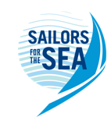

Oakcliff Harvest Regatta
Oakcliff Sailing, Oyster Bay NY
October 15, 2022
Notice of Race and Sailing Instructions All-in-One

OA: Organizing Authority, Oakcliff Sailing and the Herreshoff Marine Museum
VENUE: Oyster Bay, New York. Racing will be held on the waters of Oyster Bay, Cold Spring Harbor and/or Long Island Sound. See Attachment A - Venue and Racing Areas for the location of the venue and location of the racing areas.

SCHEDULE:
9:54 LIRR Port Jefferson Line – Get off at Syosset at 10:51
11:15: Competitors Meeting and Boat Assignments 4 South Street Oyster Bay NY 11771
11:30: Oakcliff Uber Begins at OBMC 5 Bay Ave, Oyster Bay NY 11771
12:30: Attention Signal
14:30: Racing Ceases
15:00: Awards, Brats, Beers and Laughs
3:47 and 5:47 return trains getting into Jamaica at 4:23 and 5:20 and Penn at 4:43 and 5:43
ELIGIBILITY AND ENTRY:
This regatta is open to all Oakcliff Supporters and all attendees at the America’s Cup Hall of Fame Class of 2022 Induction Ceremony being held October 14 2022. Entry Fees are welcome to be made in the form of a donation

More information here: https://www.oakcliffsailing.org/support-us

Donate directly here: https://secure.oakcliffsailing.org/np/clients/oakcliffsailing/donation.jsp?forwardedFromSecureDomain=1

Entries will be accepted on a 1st come 1st served basis and will be limited to 105 persons.
RULES:
The regatta will be governed by the current Racing Rules of Sailing, the prescriptions of the United States Sailing Association, the rules of each class of boat, and this document. If some of these rules are inconsistent, the rule in the document furthest toward the end of the list overrides the others.

Boats shall stay clear of all commercial traffic, including clammers and a boat’s failure to stay clear will be a basis for disqualification. In no case shall a Match 40 or Shields sail to within 2 boat lengths of a classic boat.
NOTICES TO COMPETITORS
If changes to the sailing instructions or other notifications are made, they will be broadcast on VHF69

FORMAT OF RACE
A modified pursuit style race will be sailed with the starting time of each fleet of boat calculated to bring all the boats together at the finish. One race shall constitute a series. Low point scoring. Costumes are encouraged but not mandated.

CLASSES:
Newport 29 (2):
- Dolphin and Mischief
- 4-8 crew assigned per boat
Shields (5):
- Teaser, Mayhem, Avatar Symphony and Whistler
- 3-5 crew assigned per boat
Match 40:
- Bow Numbers 1-8
- 5-8 crew assigned per boat

Additional Classics may be on the race course

COURSE:
The course shall be a tour of Oyster Bay and Cold Spring Harbors. Government Marks shall also be honored and treated as marks of the course.
Start between SCYC Flag Pole and G‐5 to F‐7 (port) to G‐1 (port) to F‐7 (starboard) to G‐5 (port) to F‐7 (port) to G‐1 (port) to F‐7 (starboard) to finish between SCYC Flag Pole and G‐5 – (see attached map of Oyster Bay).
STARTING AND FINISHING LINE:
The starting and finishing line will lie between the Seawanhaka flagpole and mark F (FL Green #5). A boat will sight for premature starters and record finishers from the Eastern end.

STARTING SYSTEM:
Starting Signals from Race Committee aboard Hyfoil RIB Trobatos with staggered starts based on handicap with starting signals announced on VHF Channel 69.

RECALLS:
Boats starting prematurely that do not return to restart will be penalized by having the skipper work in the kitchen to help set up the hors d’oeuvres for the trophy presentation. There will be no general recalls.

TIME LIMIT:
The time limit race is 14:00. At 14:00 boats still racing shall be scored as they stand on the racecourse and all sailors will proceed to the bar.

RADIO COMMUNICATION:
The race committee will use VHF 69. Racers are welcome to monitor this channel.
AWARDS:
Trophies will be presented at 2 South Street following the completion of sailing. Trophies may be awarded to the first and last place finishers in each class. The race committee, in consultation with the social committee, will make an award for best team costume.
If protests are filed and undecided, the trophies will be awarded based on the preliminary standings. There is no protest committee.
GREAT PUMPKIN HUNT:
Approximately 20 individually numbered pumpkins will be distributed along the racecourse. Recovered pumpkins shall be presented to the race committee ashore and points and prizes will be awarded according to a secret schedule. The maximum number of pumpkins which may be retrieved per boat is 4.

ATTACHMENT A – VENUE AND RACING AREAS

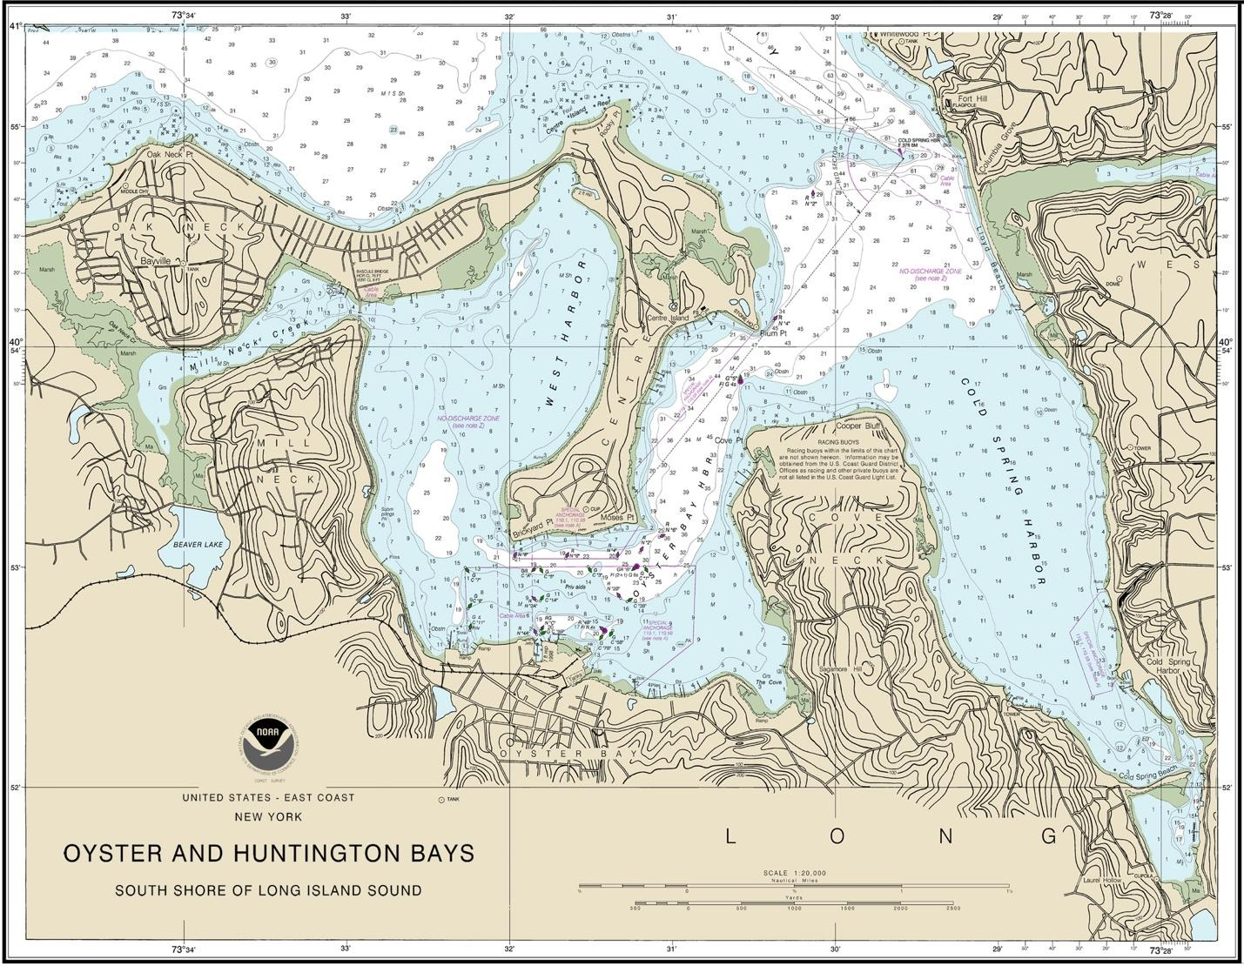

Main Hosting Venue:

Oakcliff Sailing
4 South Street
Oyster Bay, NY 11771

www.oakcliffsailing.org

(P) 516-802-0368 — (F) 516-802-3272

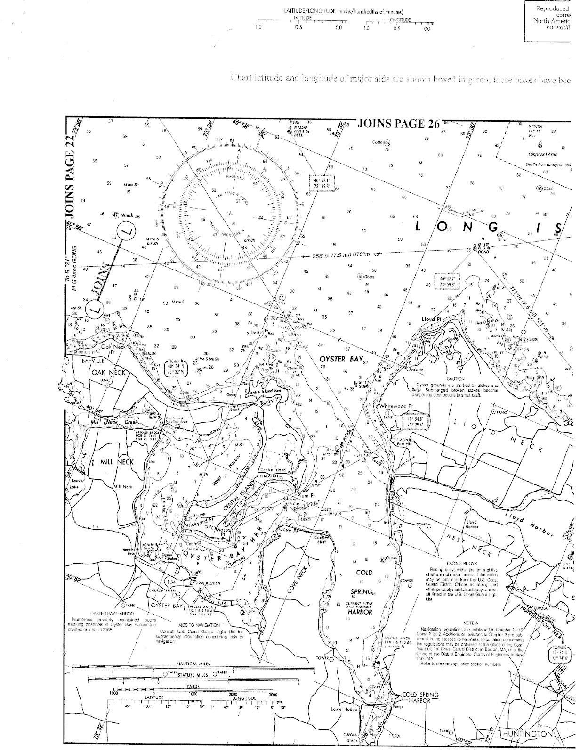

DISCLAIMER OF LIABILITY
Competitors participate in the race entirely at their own risk. See rule 3, Decision to Race. The OA, it’s associates, and appointees accept no responsibility for any loss, damage, injury, sickness, disease, or inconvenience incurred, however so caused. The failure of any of competitor to comply with any reasonable request of any Race Official or staff of the OA and its representatives may result in the disqualification of the boat, and its exclusion from the race.

MEDIA RIGHTS, CAMERAS AND ELECTRONIC EQUIPMENT
  - By participating in the Oakcliff Harvest Regatta, competitors automatically grant the OA, and their sponsors, the right in perpetuity to make, use and show, from time to time at their discretion, any motion pictures and live, taped or filmed television and other reproductions of the athlete during the period of competition without compensation.

OAKCLIFF POLICY
Whenever you are representing Oakcliff Sailing it is expected that you will behave in a professional manner. Any time you are wearing Oakcliff Sailing Center or organization branded gear, at a sponsored event, at a sailing event as part of Oakcliff Sailing, at the Oakcliff Sailing Center, or on their boats, you are representing Oakcliff. The community at large and specifically the sailing community, sponsors and suppliers, and other employees and volunteers are to be treated with respect. There is to be no harassment or discrimination. No underage drinking or promoting of underage drinking or illegal drug use is permitted while you are on Oakcliff Sailing Center property or representing the Oakcliff Sailing Center.
  - Organizing Authority - Oakcliff Sailing, 4 South Street, Oyster Bay, NY 11771
www.oakcliffsailing.org - race@oakcfliffsailing.org - (P) 516-802-0368 — (F) 516-802-3272
Race Program Director- Patrice Rachlin – regatta@oakcliffsailing.org
Executive Director - Dawn Riley - race@oakcliffsailing.org

